1. [Episode 0: Course Overview](https://marczak.io/az-900/" \l "ep00)

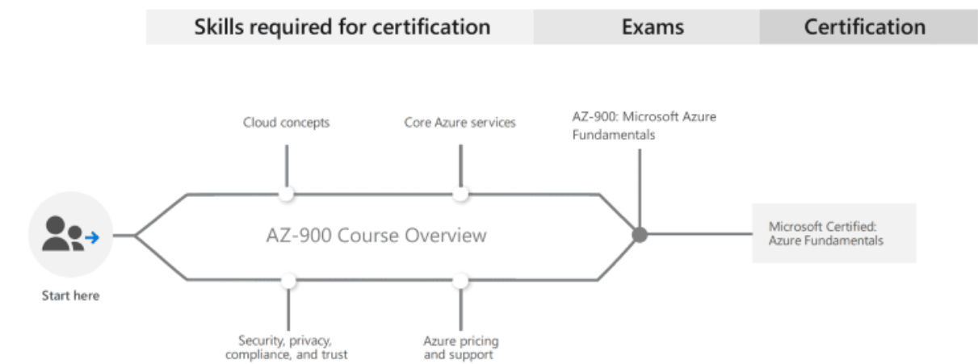

1. [Episode 1: Cloud Computing, High Availability, Scalability, Elasticity, Agility, Fault Tolerance, and Disaster Recovery](https://marczak.io/az-900/#ep01)
   1. Cloud Computing

Service delivery model over the internet (cloud). This includes but is not limited to

* **compute power** meaning servers such as windows, Linux, hosting environments, etc.
* **storage** like files and/or databases
* **networking** in azure but also outside when connecting to your company network.
* **analytics** services for visualization and telemetry data

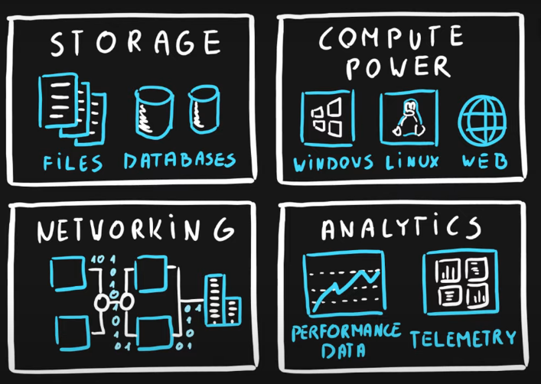

* 1. Key concepts
* **scalability** is the ability to scale, so allocate and deallocate resources at any time.

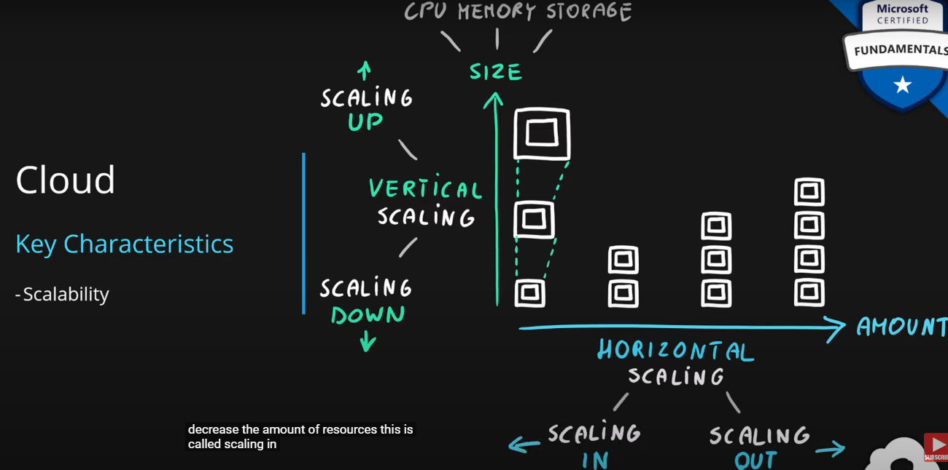

* **elasticity** is the ability to scale dynamically.

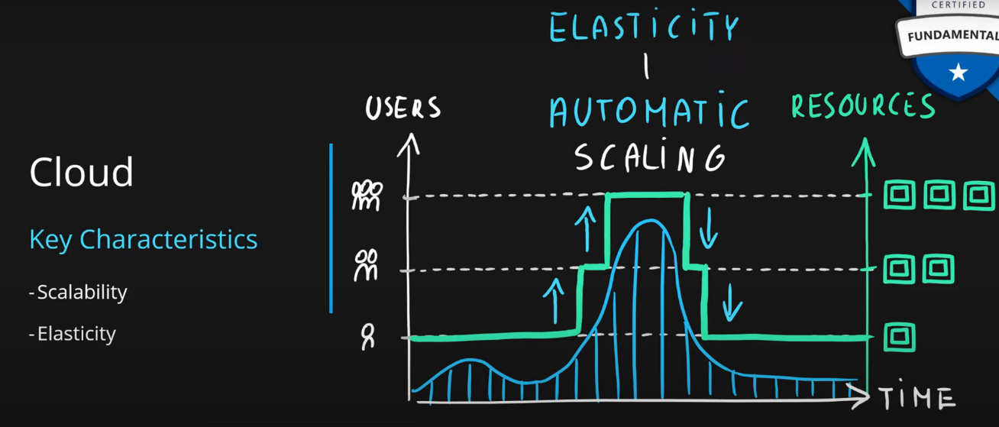

* **agility** is the ability to react fast (scale quickly)

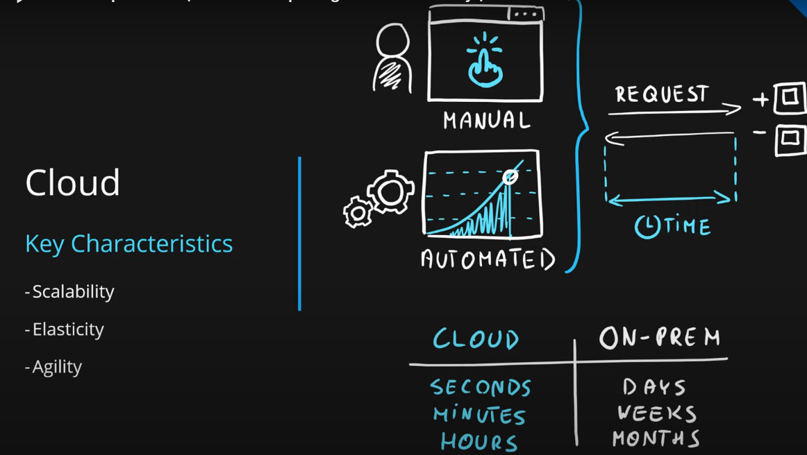

* **fault tolerance** is the ability to **maintain system uptime** while physical and service component failures happen.

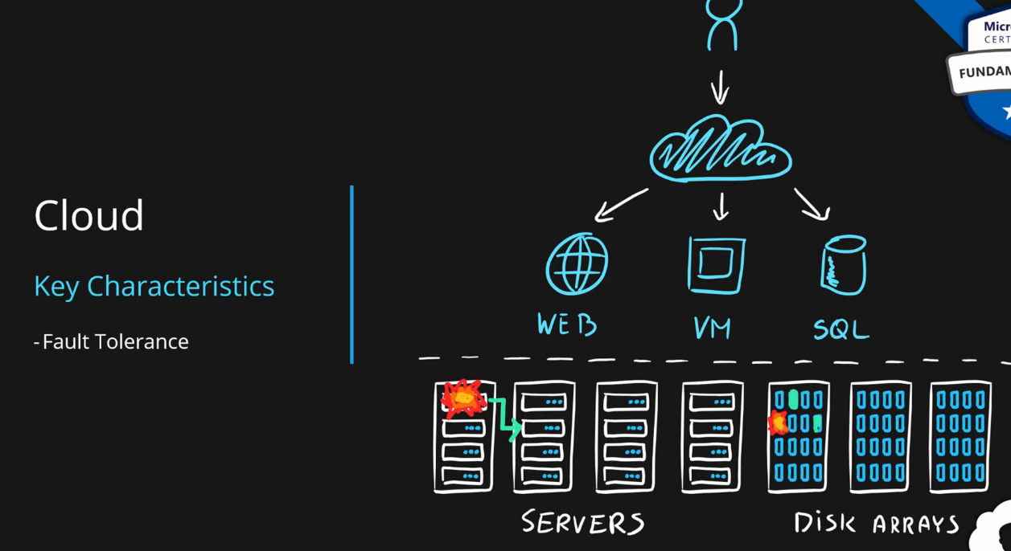

* **disaster recovery** is the process and design principle which allows a system **to recover** from natural or human-induced disasters

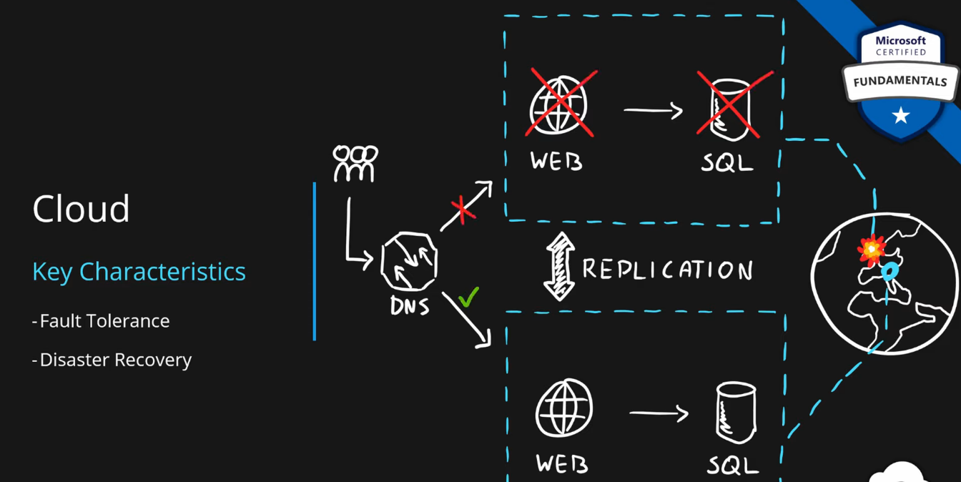

* **high availability** is the agreed level of operational uptime for the system. It is a simple calculation of system uptime versus the whole lifetime of the system.
  + **availability = uptime/(uptime + downtime)**

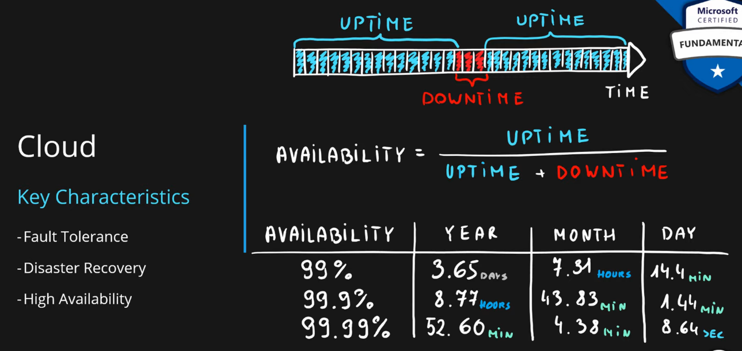

1. [Episode 2: Principles of economies of scale](https://marczak.io/az-900/#ep02)

The principle of economies of scale states that ***as companies grow they become more effective at managing shared operations.*** Be that HR and hiring, taxes, accounting, internal operations, marketing, big purchases via contracts meaning better discounts, etc., etc.

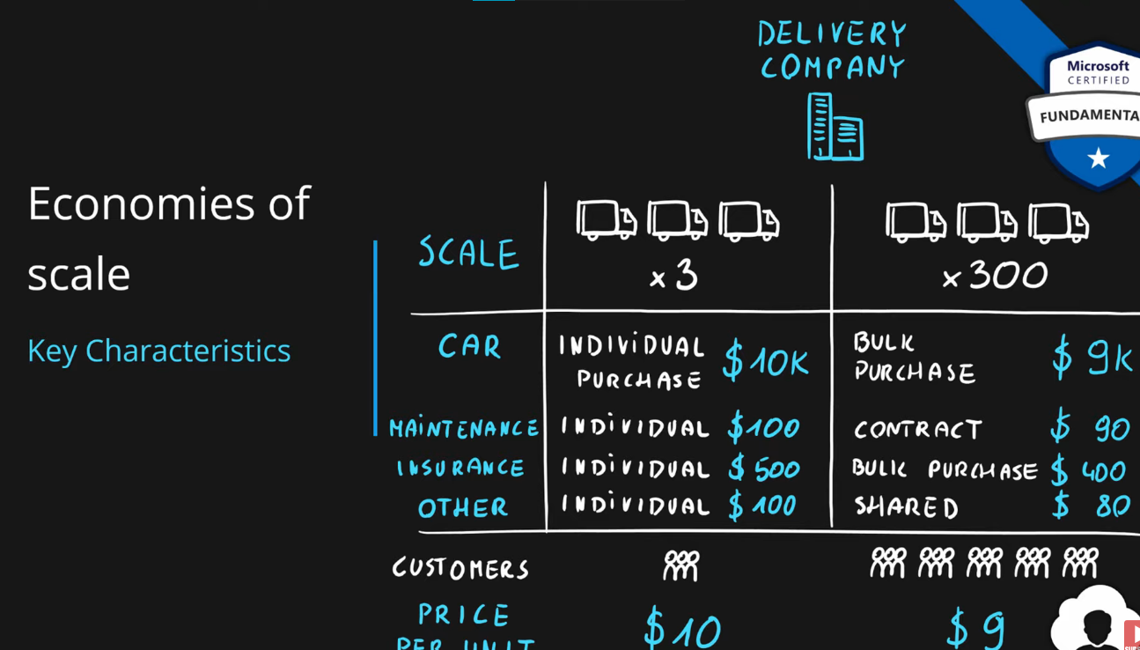

Because of those, **companies can save/earn more which in return allows for reduction in cost of their services to their customers**. This is so-called ‘price per unit’.

It’s not possible to go to 0 because, in the end, some underlying infrastructure needs to run to provide the services. But the larger the scale the more benefits can be passed to customers.

In fact, on the current scale, Microsoft can already offer multiple services for free due to how small a fraction of the cost it is for them.

Thus, As Company grows, cost decreases, or we can say that:

Company growth ∝ 1/Cost per user

1. [Episode 3: Capital Expenditure (CapEx) vs Operational Expenditure (OpEx) and their differences](https://marczak.io/az-900/#ep03)
   1. ***Economies of scale*** is the ability to do things more efficiently or at a lower cost per unit when operating at a larger scale.

|  | ***Capital Expenditure*** | ***Operational Expenditure*** |
| --- | --- | --- |
| **Definition** | CapEx is the spending of money on physical infrastructure up front and then deducting that expense from your tax bill over time. CapEx is an upfront cost, which has a value **that reduces over time**. | OpEx is spending money on services or products now and being billed for them now. You can deduct this expense from your tax bill in the same year. There's **no** upfront cost. **You pay for a service or product as you use it.** |
| **What Costs?** | * Server cost * Storage cost * Network cost * Backup and archive cost * Organization continuity and disaster recovery cost * Datacenter infrastructure costs * Technical personnel | * Leasing software and customized features * Scaling charges based on usage/demand instead of fixed hardware or capacity.Billing categories can include the number of users or CPU usage time, allocated RAM, I/O operations per second (IOPS), and storage space. * Billing at the user or organization level. |
| **Upfront cost** | Significant | None |
| **Ongoing cost** | Low | Based on usage |
| **Tax Deduction** | Over time | Same year |
| **Early Termination** | No | Anytime |
| **Maintenance** | Significant | Low |
| **Value over time** | Lowers | No change |

1. [Episode 4: Consumption-based model](https://marczak.io/az-900/#ep04)

The consumption-based model is a **pricing model** used in the cloud so that customers are only charged **based on their resource usage**.

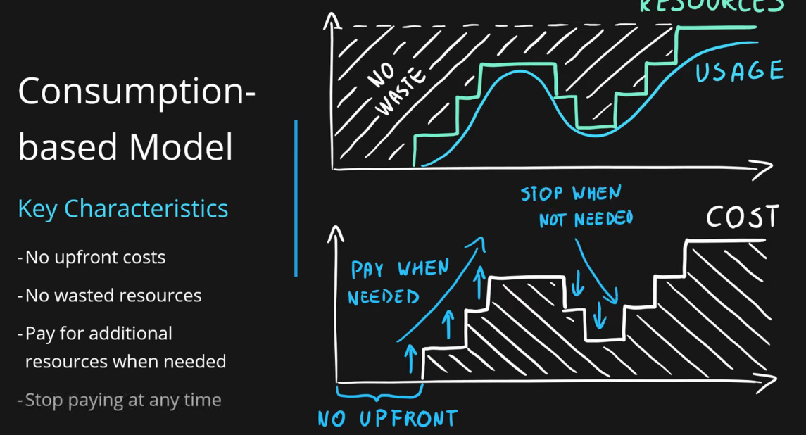

This model is characterized by:

* **No associated upfront cost.**
* **No wasted resources** as such *no charges are incurred for unused resources*\*. Unused in this case is different per service. For instance, blob storage that stores any data is considered to be used, as it consumes the storage space. Virtual Machines that are running consume CPU, memory and other resources even if there isn’t any traffic. Hence they are considered to be used and will incur charges.
* **Pay for what you need only.**
* **Stop paying when you don’t use resources.**

**Consumption is the virtual metric used to calculate how much each resource (service) in Azure was used. Each service has many smaller metrics that track its consumption to offer the best possible pricing model**. Those metrics are tracked on a very **granular level**.

1. [Episode 5: IaaS, PaaS, SaaS, and their differences](https://marczak.io/az-900/#ep05)

## **Service Models responsibilities**

**As a service** means which party will manage the layer and all the layers below.

* **Software** layer consists of the application (application code and set) & the application data.
* **Platform** layer means all the supporting software and the operating system required to host the application.
* **Infrastructure** layer consists of hardware the infrastructure and virtualization required to host the platform.

| **Layer** | **Layer** |
| --- | --- |
| Application | Software |
| Data | Software |
| Runtime | Platform |
| Middleware | Platform |
| Operating System | Platform |
| Virtualization | Infrastructure |
| Servers | Infrastructure |
| Networking | Infrastructure |
| Storage | Infrastructure |

## **Responsibility Matrix**

As such following table represents responsibilities

| ***Layer*** | ***On-Premises*** | ***IaaS*** | ***PaaS*** | ***SaaS*** |
| --- | --- | --- | --- | --- |
| **Application** | You | You | You | Cloud provider |
| **Data** | You | You | You | Cloud provider |
| **Runtime** | You | You | Cloud provider | Cloud provider |
| **Middleware** | You | You | Cloud provider | Cloud provider |
| **Operating System** | You | You | Cloud provider | Cloud provider |
| **Virtualization** | You | Cloud provider | Cloud provider | Cloud provider |
| **Servers** | You | Cloud provider | Cloud provider | Cloud provider |
| **Networking** | You | Cloud provider | Cloud provider | Cloud provider |
| **Storage** | You | Cloud provider | Cloud provider | Cloud provider |
| **Definition** | Cloud manages nothing. You manage everything – Infrastructure, Platform and Software | Cloud Manages Infrastructure. You manage - Platform (OS, Middleware, Runtime) and Software (Data & Apps). | You manage only Software. Cloud manages Infrastructure(N/W, H/W & Virtualization) and Platform. | You manage nothing. Cloud manages everything. |
| **Use Cases** |  | Migration of Workloads Test and Development Storage, Backups & Recovery | Development Framework. Analytics and BI. AI and ML. | Buying of-the-shell applications. |
| **Examples** | Server at your home location. | VM, Virtual Networks, Managed Disks | SQL, App Services, Logic Apps, Function Apps, etc. | One Drive, Outlook, Skype, etc. |

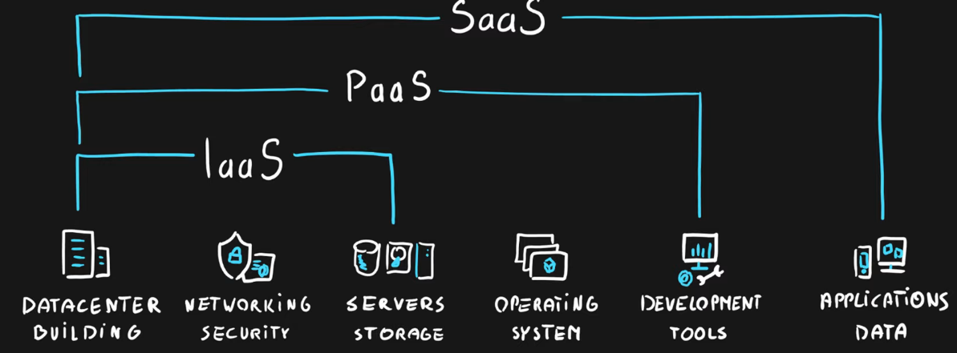

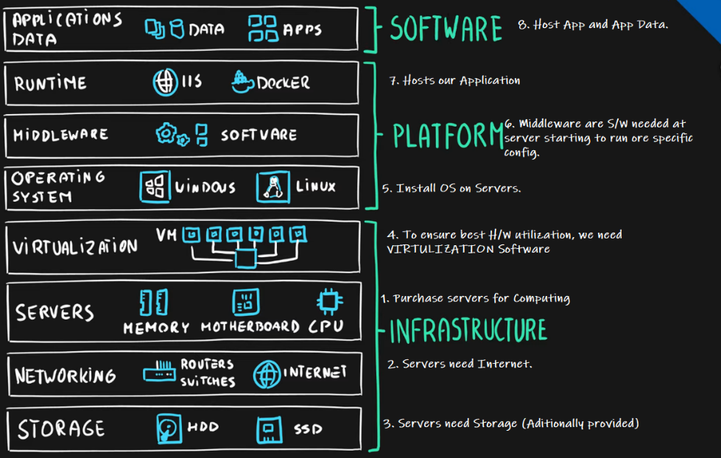

1. [Episode 6: Public, Private, Hybrid cloud and their differences](https://marczak.io/az-900/#ep06)

## **Cloud Deployment Model**

**Cloud Deployment Model** is a separation that describes where are the company resources deployed. Whether this is in a public cloud provider environment or private data center.

The below table presents high-level deployment model separation

| Layer | Cloud Provider | Own Datacenter |
| --- | --- | --- |
| **Public** | ✅ | ✖ |
| **Hybrid** | ✅ | ✅ |
| **Private** | ✖ | ✅ |

## **Public Cloud**

| Cloud Provider | Own Datacenter |
| --- | --- |
| ✅ | ✖ |

|  |  |
| --- | --- |
| **Key Characteristics**   * Everything runs on cloud provider hardware. * No local hardware. * Some services share hardware with other customers.   **Advantages**   * No CapEx (**No initial investment**). * High Availability. * Agility. * Pay as you Go (PAYG) pricing. * No hardware maintenance. * No deep technical skills are required.   **Disadvantages**   * Not all security and compliance policies can be met. * No ownership over the physical infrastructure. * Rare specific scenarios can’t be done. |  |

## **Private Cloud**

| Cloud Provider | Own Datacenter |
| --- | --- |
| ✖ | ✅ |

|  |  |
| --- | --- |
| **Key Characteristics**   * Everything runs on your own data center. * Self-service should be provided. * You maintain the hardware.   **Advantages**   * Can support any scenario. * Total control over security and infrastructure. * Can meet any security and compliance policy.   **Disadvantages**   * Initial **investment is required** (CapEx). * Limited agility constrained by server capacity and team skills. * Very dependent on IT skills & expertise. |  |

## **Hybrid Cloud**

| Cloud Provider | Own Datacenter |
| --- | --- |
| ✅ | ✅ |

|  |  |
| --- | --- |
| **Key Characteristics**   * Combines both Public & Private cloud.   **Advantages**   * Great flexibility * You can run any legacy apps in private cloud. * Can utilize existing infrastructure. * Meet any security& compliance requirements. * Can take advantage of all public cloud benefits.   **Disadvantages**   * Can be more expensive. * Complicated to manage due to larger landscape. * Most dependent on IT skills & expertise from all three models |  |

* 1. AZURE – Plans & Subscriptions

You **cannot merge two subscriptions into a single subscription**. However, you can

* **move some Azure resources** from one subscription to another.
* **transfer ownership of a subscription** and **change the billing** type for a subscription.
* A company **can have multiple subscriptions** and store resources in the different subscriptions. However, **a resource instance can exist in only one subscription**.
* You can use the **same account to manage multiple subscriptions**. You can create an additional subscription for your account in the Azure portal. You may want an additional subscription to avoid hitting subscription limits, to create separate environments for security, or to isolate data for compliance reasons.
* You need an ***Azure Active Directory account to manage a subscription***, not a Microsoft account.  
  An account is created in the Azure Active Directory when you create the subscription. Further accounts can be created in the Azure Active Directory to manage the subscription.

**Additional Azure subscriptions:**

* + **Environments**: When managing your resources, you can choose to create subscriptions to set up separate environments for development and testing, security, or to isolate data for compliance reasons. This is particularly useful because resource access control occurs at the subscription level.

**Organizational structures**: You can create subscriptions to reflect different organizational structures. For example, you could limit a team to lower-cost resources, while allowing the IT

* 1. Web Tier Plans

|  |  |  |  |  |  |
| --- | --- | --- | --- | --- | --- |
| PLAN 🡪  Feature | FREE(F) | SHARED(D) | BASIC(B) | STANDARD(S) | PREMIUM(P) |
| SIZES | 1-F1 | 1-D1 | 3-B1,B2,B3 | 3-S1,S2,S3 | 3-P1,P2,P3 |
| STORAGE | 1 GB | 1 GB | 10 GB | 50 GB | 250 GB |
| DOMAINS |  | Custom | Custom | Custom | Custom |
| SSL |  |  | SNI SSL Only | SNI SSL + IP SSL | SNI SSL + IP SSL |
| SCALEOUT |  |  | 3 Instances (Manual Only) | 10 Instances (Auto) | 20 Instances (auto) |
| DAILY BACKUP |  |  |  | Yes | Yes – 50 Times |
| DEPLOYMENT SLOTS |  |  |  | 5 | 20 |
| TRAFFIC MANAGER SUPPORT |  |  |  | Yes | Yes |
| DEBUGGER SUPPORT CONNECTIONS | 1 | 1 | 5 | 5 | 5 |
| APPS SUPPORTED [BITS] | 32 | 32 | 32, 64 | 32, 64 | 32, 64 |
| SLA(s) |  |  | **99.95%** | **99.95%** | **99.95%** |
| HYBRID CONNECTIONS |  |  | 5 | 25 | 200 |
| CPU RESOURCES | 60 min/day | 240 min/day |  |  |  |